1. **Write file:**

File.js:

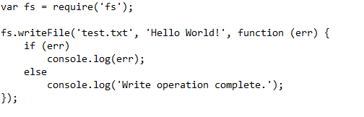

1. **Append file:**

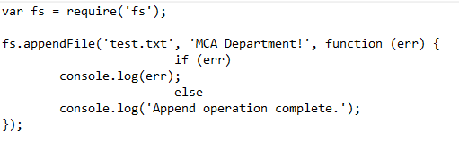

1. **Delete file:**

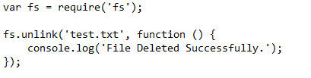

1. **Asynchronous file opening:**

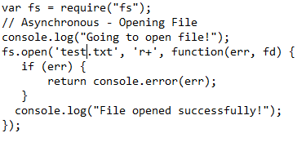

1. **Web based applications with File operations:**

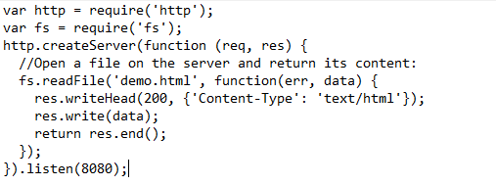

**Demo.html**

Hi Welcome to Department of MCA

1. **Renaming a file synchronously:**

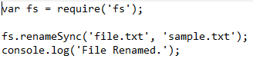

Note: Make sure you have crated file.txt